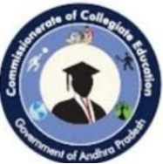
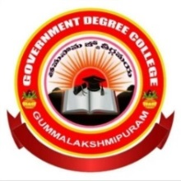
Govt.DegreeCollege, Gummalakshmipuram
ParvathipuramManyam District
www.gdcglpuram.ac.in
Name of the Event: Sarojini Naidu Birth Anniversary Day
Date : 13-02-2025
Department : English
Lecturers Attended: 08
Students Attended: 60
Sarojini Naidu birth anniversary day on 13 February GDC Gummalakshmipuram introduction the department of English conducted a special program on 13 February to commemorate the life and work of Sarojini Naidu one of India's most celebrated points and freedom fighters. Principal Dr. T. Sreevaram garu addressed the students to explain Sarojini Naidu's life achievements contribution to Indian literature and freedom movement. The program featured students reciting a poems a fact sheet presentation and speech on your life and legacy Students poetry recitation Munna from first BA Durga Prasad from first become Triveni from first mpcs students recited some of Sarojini Naidu’s poems most famous poems including
- Bangle sellers
- Falcon bridge
- The Indian weavers
- The bird of time
4 the golden threshold the students recitations were impressive and they brought out the essence of Sarojini Naidu’s poetry which is known for its lyricism imagery and patriotism.
Factsheet presentation sexy presentation was also made highlighting Sarojini Naidu’s life achievements and contributions to Indian actress and the freedom movement it is presented by Durga Prasad from first B com. They are include Sarojini Naidu was the first Indian woman to become the President of the INC She was known as the nightingale of India for her beautiful poetry She played a key role in the Indian independence movement the first woman
Governor of state in India she established women’s Indian association Air first collection of poems was called the golden threshold Speech on Sarojini Naidu’s life and legacy. The speech was delivered by Poornima from first mpcs the speech emphasized hair carriage conviction creativity and how she continuous to inspired generations of Indians she was born on 13th 1879 in HYD to Bengali family. Your father was Aghori nath chattopadhyay the principle of Nizam College in HYD. Her mother was the sundara Devi. She studied in Madras London and Cambridge. Shiva's prelims in several languages.
Conclusion: the program was huge success Happy Birthday Amma and it helped to create awareness among students about Sarojini Naidu’s life works and legacy. We hope to organize more such problems the future to promote Indian culture literature and history. Vice principal sir D. Ramaiah Garu IQAC coordinator V. Kalpana Garu women empowerment member A. Srivani Garu and all step members participated in the program.
